**A. Goals**

The goals of Configuration Management (CM) on this project are very similar to the goals of other projects.  Specifically, Introduction to the Team Software Process (Humphrey, 62) describes the overall goals of CM as:

G1. Recorded copies of each version of each product element

G2. A record of all changes made to every baseline

G3. Who made the change

G4. When they made the change

G5. What the change was

G6. Why they made the change

In order to accomplish G1, Google Code will be used to maintain versioned copies of each element of the project.  Google Code uses Subversion (SVN) technology to store each file as a separate entity during a "SVN Commit" and displays the current contents of the code base with "SVN Update".  The team will be using Eclipse with the Subclipse plugin as a client to Google Code.  Optionally, for document management, the team can use Tortoise SVN outside of the Eclipse IDE to version documents and other files.

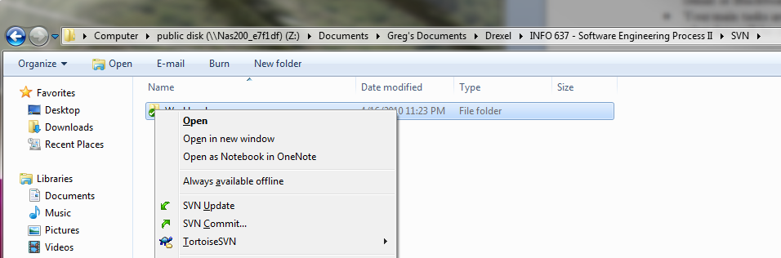

**Tortoise SVN right-click options when used in Microsoft Windows**

Google Code maintains a list of changesets acting as an SVN server.  A changeset is simply a list of items that have changed since the previous version.  Using this fact, Google Code can display changes that have been made to every baseline (G2).

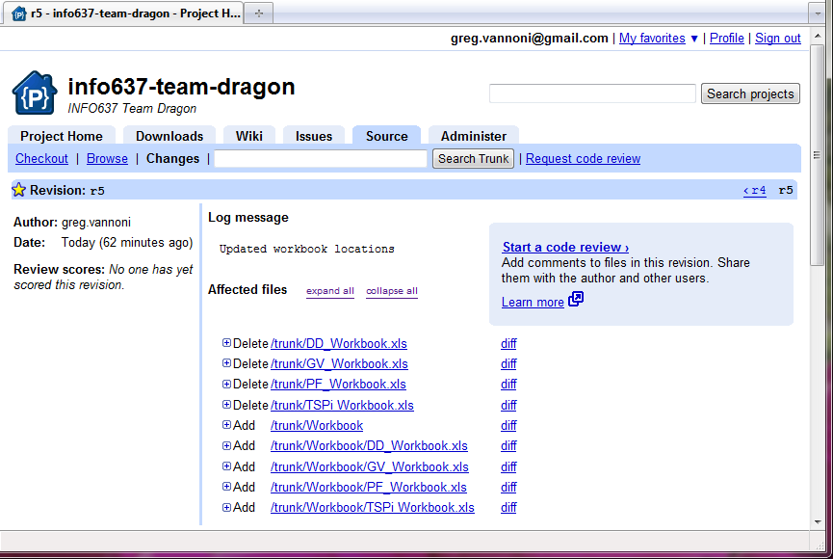

**A change set listed in Google Code for Team Dragon**

The figure above illustrates how Google Code tracks "revisions" to files and directories as part of the system's baseline.  Displayed are the following details:

* Authors Name (satisfies G3)
* Date change was commited (satisfies G4)
* Author's log message (satisfies G6)
* Affected files (satisfies G5)

If these files were code, a "diff" or difference could be ran to display added, deleted or modified lines of code (enhances G5).

**B. The Configuration Control Board (CCB)**

The CCB exists ensure that the product baseline is secure and only is modified after proper justification.  Items to be merged into the baseline will be inspected to ensure quality and perform the actions they were intended to.    
  
The items to be reviewed by the CCB are as follows (Humphrey, 323):

* The approved list of configuration items
* Requirements
* Product design
* Program source code
* Test materials and test results
* Product design standards (ie: module and system naming standards, interface standards, standard messages and screens, and the reusable program library)

The CCB is chaired by the support manager and includes the team leader and development manager (and optionally the Quality/Process Manager).  The board will have a weekly rhythm to discuss upcoming baseline changes, quality issues and defects incurred during the testing phase.

**C. Tools and Facilities**

The following tools and applications will be used to execute configuration management for the project.  
  
Configuration Management of Software

* Google Code
  + Subversion (SVN)
  + Defect and enhancement tracking
* Eclipse IDE with Subclipse

Configuration Management of Documents

* Tortoise SVN
* Google Docs
* Google Code
* Microsoft Office

Google Code appears in both lists because it allows for defect/enhancement tracking for both code and documents.  Subversion, the underlying layer of Google Code also allows for version tracking of documents and code.